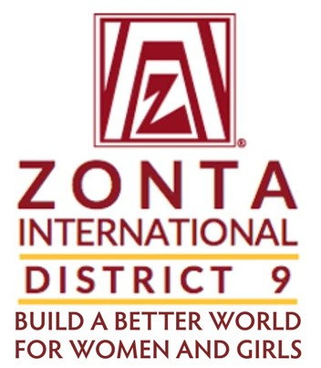

(Copy to D9 Governor and Area Directors)

May 14, 2025

Dear Club Presidents,

Thank you for accepting this important leadership role in Zonta as Club President! I’m looking forward to finding ways that we can all support you in this role in any way you may need it – please just let us know! Your role is one of the most important roles in Zonta and we are delighted to work together with you and your club to help you achieve your goals for this year.

This letter involves club membership. Membership in Zonta International is the lifeblood of our organization and the power behind our work together to build a better world for women and girls! Membership in Zonta also develops leadership for the future, allowing us to stand for gender equality in education, economy, health, climate change and more - now and in the future.

With this in mind, District 9 has created a Membership Grant this biennium, to encourage and support clubs in building their club membership. These grants offer up to $250 to support clubs in building and retaining membership at the club level.

Attached to this letter you will find the District 9 Membership Grant proposal form to use for your Club’s application for this grant. This grant is open to all established clubs in District 9. However, preference will be given to clubs that have 15 members or less. If your club is struggling, we urge you to consider using this opportunity to thoughtfully and strategically work on building your club’s membership.

The deadline for submission of a proposal is June 1, 2025. If approved, the grant awarded must be used prior to May 31, 2026, to strengthen club member recruitment and/or retention. Grant proposal applications should be returned to me no later than midnight Pacific Time on June 1, 2025 to: [D9ltgov2426@gmail.com](mailto:D9ltgov2426@gmail.com)

Please contact me with any questions at (818) 692-2937.

Looking forward to receiving your club’s membership grant proposal!

Best wishes,

Nicole Miller

District 9 Lt. Governor & Membership Chair

**D9 Membership Grant Proposal Form**

Club Name: Current Membership:

Name of Requestor/Contact:

Email and phone number:

Proposed Date of Event/Project:

Description of Event/Program or Project:

How will event be advertised (describe all):

What is the requested amount?

How will D9 funds be used?

Are there other funding sources that you utilizing to execute this event/project (include in-kind contributions)?

Describe any specific focus for membership (e.g., young professionals, women business owners):

Describe the plan to follow-up with prospective members:

Describe how your club will evaluate the event:

**Submit** this completed form for District 9 Board review and approval via email **to** District 9 Lt.

Governor, Nicole Miller, at D9LtGov2426@gmail.com. Please reach out with any questions to Lt. Governor Nicole or your Area Director.

**If D9 grant funds are approved for use, in order to seek reimbursement**:

1. Complete the event or project.
2. Submit receipts to District Treasurer, Gwen Black, by scanned copies via email ([gjkblack@gmail.com](mailto:gjkblack@gmail.com)). Please also provide the club treasurer’s name and mailing address.